**Industrial Internship at Elite Tech Intern.**

This report showcases advanced SQL queries written as part of Task 2 of the Elite Tech Intern program. The task focuses on analysing database trends and patterns using:

* Window Functions (e.g., ROW_NUMBER, RANK, NTILE, LAG, etc.)
* Common Table Expressions (CTEs) for modular, readable queries
* Subqueries for filtering, comparison, and aggregation

Each query has been executed on the EmployeeDB database, and corresponding outputs have been captured and included below as screenshots. This demonstrates both query logic and practical results from real sample data.

**Task 2- Data Analysis & Complex Queries**

* **Window Functions**

-- 1. ROW_NUMBER: Assign row number based on salary.

SELECT e.name, s.salary,

ROW_NUMBER() OVER (ORDER BY s.salary DESC) AS row_num

FROM Employees e

JOIN Salaries s ON e.emp_id = s.emp_id;

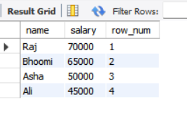

*Assigns a unique row number to each employee in descending salary order.*

2. RANK: Rank employees based on salary.

SELECT e.name, s.salary,

RANK() OVER (ORDER BY s.salary DESC) AS salary_rank

FROM Employees e

JOIN Salaries s ON e.emp_id = s.emp_id;

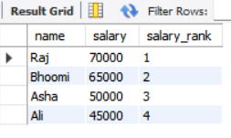

*Ranks employees by salary, allowing gaps for duplicate values.*

3. DENSE_RANK – Dense rank without gaps.

SELECT e.name, s.salary,

DENSE_RANK() OVER (ORDER BY s.salary DESC) AS dense_rank

FROM Employees e

JOIN Salaries s ON e.emp_id = s.emp_id;

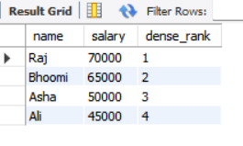

*Ranks employees by salary without skipping any ranks.*

4. NTILE – Divide into salary groups.

SELECT e.name, s.salary,

NTILE(2) OVER (ORDER BY s.salary DESC) AS salary_group

FROM Employees e

JOIN Salaries s ON e.emp_id = s.emp_id;

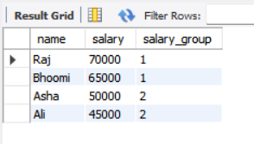

*Divides employees into two equal-sized salary groups.*

5. LAG – Previous salary.

SELECT e.name, s.salary,

LAG(s.salary, 1) OVER (ORDER BY s.salary) AS previous_salary

FROM Employees e

JOIN Salaries s ON e.emp_id = s.emp_id;

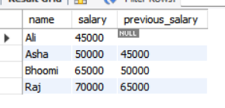

*Shows each employee’s previous salary in sorted order.*

6. LEAD – Next salary.

SELECT e.name, s.salary,

LEAD(s.salary, 1) OVER (ORDER BY s.salary) AS next_salary

FROM Employees e

JOIN Salaries s ON e.emp_id = s.emp_id;

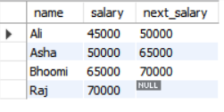

*Shows each employee’s next salary in sorted order.*

7. CUME_DIST – Cumulative salary distribution.

SELECT e.name, s.salary,

CUME_DIST() OVER (ORDER BY s.salary) AS cum_dist

FROM Employees e

JOIN Salaries s ON e.emp_id = s.emp_id;

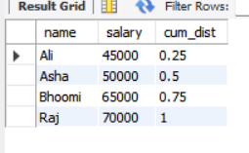

*Displays cumulative distribution of salaries.*

8. PERCENT_RANK – Salary percentile.

SELECT e.name, s.salary,

PERCENT_RANK() OVER (ORDER BY s.salary) AS percent_rank

FROM Employees e

JOIN Salaries s ON e.emp_id = s.emp_id;

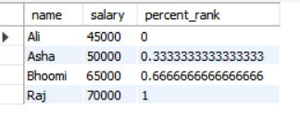

*Shows each employee’s salary percentile rank.*

9. FIRST_VALUE – First salary.

SELECT e.name, s.salary,

FIRST_VALUE(s.salary) OVER (ORDER BY s.salary) AS min_salary

FROM Employees e

JOIN Salaries s ON e.emp_id = s.emp_id;

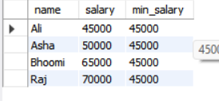

*Returns the lowest salary from the result.*

10. LAST_VALUE – Last salary.

SELECT e.name, s.salary,

LAST_VALUE(s.salary) OVER (

ORDER BY s.salary

ROWS BETWEEN UNBOUNDED PRECEDING AND UNBOUNDED FOLLOWING

) AS max_salary

FROM Employees e

JOIN Salaries s ON e.emp_id = s.emp_id;

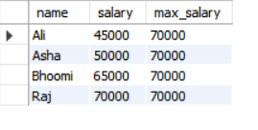

*Returns the highest salary from the result.*

11. AVG OVER – Global average.

SELECT e.name, s.salary,

AVG(s.salary) OVER () AS avg_salary

FROM Employees e

JOIN Salaries s ON e.emp_id = s.emp_id;

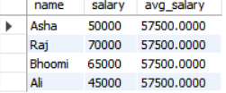

*Calculates the average salary across all employees.*

12. AVG PARTITION BY – Department average.

SELECT e.name, d.dept_name, s.salary,

AVG(s.salary) OVER (PARTITION BY d.dept_name) AS dept_avg

FROM Employees e

JOIN Salaries s ON e.emp_id = s.emp_id

JOIN Departments d ON e.dept_id = d.dept_id;

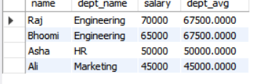

*Calculates the average salary per department.*

13. SUM PARTITION BY – Total department salary.

SELECT e.name, d.dept_name, s.salary,

SUM(s.salary) OVER (PARTITION BY d.dept_name) AS total_salary_per_dept

FROM Employees e

JOIN Salaries s ON e.emp_id = s.emp_id

JOIN Departments d ON e.dept_id = d.dept_id;

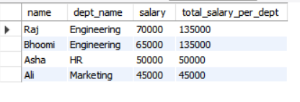

*Shows total salary for each department.*

14. COUNT PARTITION BY – Department employee count.

SELECT e.name, d.dept_name,

COUNT(*) OVER (PARTITION BY d.dept_name) AS dept_count

FROM Employees e

JOIN Departments d ON e.dept_id = d.dept_id;

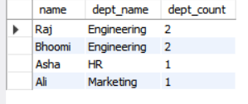

*Counts how many employees are in each department.*

15. MIN PARTITION BY – Department minimum salary.

SELECT e.name, d.dept_name, s.salary,

MIN(s.salary) OVER (PARTITION BY d.dept_name) AS min_dept_salary

FROM Employees e

JOIN Salaries s ON e.emp_id = s.emp_id

JOIN Departments d ON e.dept_id = d.dept_id;

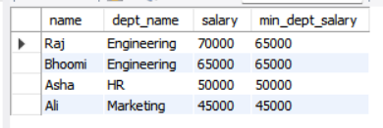

*Finds the lowest salary in each department.*

16. MAX PARTITION BY – Department maximum salary.

SELECT e.name, d.dept_name, s.salary,

MAX(s.salary) OVER (PARTITION BY d.dept_name) AS max_dept_salary

FROM Employees e

JOIN Salaries s ON e.emp_id = s.emp_id

JOIN Departments d ON e.dept_id = d.dept_id;



*Finds the highest salary in each department.*

17. ROW_NUMBER PARTITION BY – Row number within department.

SELECT e.name, d.dept_name, s.salary,

ROW_NUMBER() OVER (PARTITION BY d.dept_name ORDER BY s.salary DESC) AS row_in_dept

FROM Employees e

JOIN Salaries s ON e.emp_id = s.emp_id

JOIN Departments d ON e.dept_id = d.dept_id;

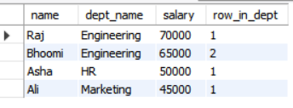

*Assigns row numbers within each department.*

18. RANK PARTITION BY – Salary rank within department.

SELECT e.name, d.dept_name, s.salary,

RANK() OVER (PARTITION BY d.dept_name ORDER BY s.salary DESC) AS rank_in_dept

FROM Employees e

JOIN Salaries s ON e.emp_id = s.emp_id

JOIN Departments d ON e.dept_id = d.dept_id;

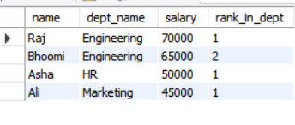

*Ranks salaries within each department.*

19. DENSE_RANK PARTITION BY – Dense rank within department.

SELECT e.name, d.dept_name, s.salary,

DENSE_RANK() OVER (PARTITION BY d.dept_name ORDER BY s.salary DESC) AS dense_rank_in_dept

FROM Employees e

JOIN Salaries s ON e.emp_id = s.emp_id

JOIN Departments d ON e.dept_id = d.dept_id;

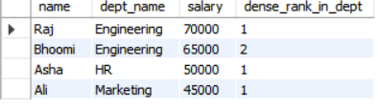

*Ranks salaries within each department without gaps.*

* **Common Table Expressions (CTEs)**

**1. CTE for employees with salary above average:**

WITH HighEarners AS (

SELECT e.emp_id, e.name, s.salary

FROM Employees e

JOIN Salaries s ON e.emp_id = s.emp_id

WHERE s.salary > (SELECT AVG(salary) FROM Salaries)

)

SELECT * FROM HighEarners;

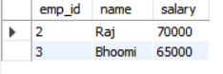

*This query returns a list of employees whose salary is greater than the company’s average salary.*

**2. CTE for department-wise total salary:**

WITH DeptSalary AS (

SELECT d.dept_name, SUM(s.salary) AS total_salary

FROM Employees e

JOIN Salaries s ON e.emp_id = s.emp_id

JOIN Departments d ON e.dept_id = d.dept_id

GROUP BY d.dept_name

)

SELECT * FROM DeptSalary;

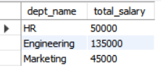

*It calculates the total salary paid by each department.*

**3. CTE for employee with latest hire date:**

WITH LatestHire AS (

SELECT *

FROM Employees

WHERE hire_date = (SELECT MAX(hire_date) FROM Employees)

)

SELECT * FROM LatestHire;

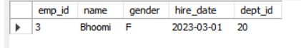

*It retrieves the employee who was hired most recently.*

* **Subqueries**

1. **Employees earning more than Raj:**

SELECT name FROM Employees

WHERE emp_id IN (

SELECT s.emp_id FROM Salaries s

WHERE s.salary > (SELECT salary FROM Salaries WHERE emp_id = 2)

);



*This query is designed to return the names of employees who earn more than Raj.  
In the current dataset, Raj has the highest salary, so no employee meets this condition — which is why the result is empty.*

1. **Departments with average salary above 60000:**

SELECT dept_name FROM Departments

WHERE dept_id IN (

SELECT e.dept_id FROM Employees e

JOIN Salaries s ON e.emp_id = s.emp_id

GROUP BY e.dept_id

HAVING AVG(s.salary) > 60000

);

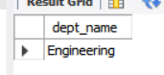

*Finds departments where the average salary of employees is more than 60,000.*

1. **Employees with the highest bonus:**

SELECT name FROM Employees

WHERE emp_id IN (

SELECT emp_id FROM Salaries

WHERE bonus = (SELECT MAX(bonus) FROM Salaries)

);

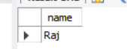

*Shows names of employees who received the maximum bonus.*

**4. Project with max hours:**

SELECT proj_name FROM Projects

WHERE hours_worked = (SELECT MAX(hours_worked) FROM Projects);



*Gives the name of the project that has the highest number of hours worked*.

1. **Names of employees not working on any project:**

SELECT name FROM Employees

WHERE emp_id NOT IN (

SELECT DISTINCT emp_id FROM Projects

);



*This query checks for employees who are not assigned to any project.  
Since all employees in the dataset are assigned to at least one project, the query returns no output.*

**6. Total number of projects per employee (with subquery in SELECT):**

SELECT e.name,

(SELECT COUNT(*) FROM Projects p WHERE p.emp_id = e.emp_id) AS total_projects

FROM Employees e;

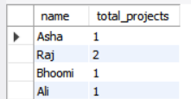

*Displays each employee’s name with the total number of projects they are working on.*

* *Note: Some queries like Subquery 1 and 5 may return no output due to the nature of the current dataset. This indicates that no rows met the specified condition — not an error in the query.*